1. Write a query to count the number of employees in each department by id. Order the information by deparment_id, then by employees count. Submit your queries with the MySQL prepare DB & run queries strategy.

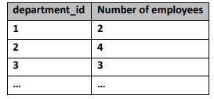

1. Write a query to calculate the average salary in each department. Order the information by department_id. Round the salary result to two digits after the decimal point. Submit your queries with the MySQL prepare DB & run queries strategy.

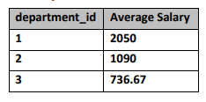

1. Write a query to retrieve information about the departments grouped by department_id with minumum salary higher than 800. Round the salary result to two digits after the decimal point. Submit your queries with the MySQL prepare DB & run queries strategy.



1. Write a query to retrieve the count of all appetizers (category id = 2) with price higher than 8. Submit your queries with the MySQL prepare DB & run queries strategy.
2. Write a query to retrieve information about the prices of each category. The output should consist of: • Category_id • Average Price • Cheapest Product • Most Expensive Product See the examples for more information. Round the results to 2 digits after the decimal point. Submit your queries with the MySQL prepare DB & run queries strategy.

